Task:03 29-06-2026
Sub: full about git

How to create the file on the git and how to add and commit it
1)Create the files add and commit it
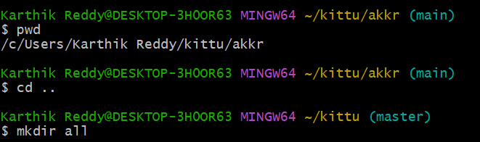
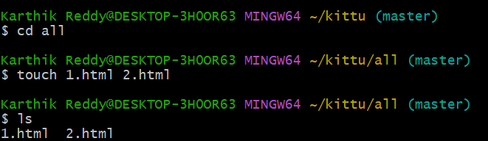
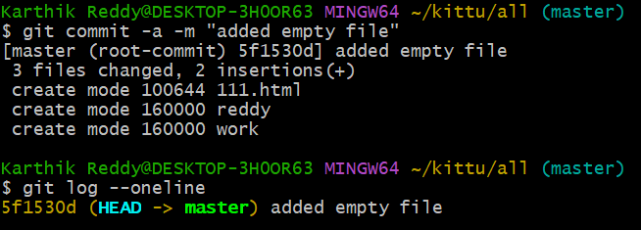

2) write the code to it add and commit it
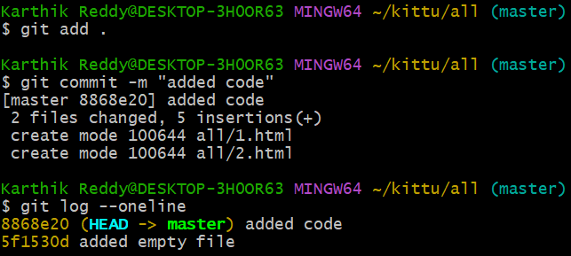

How to add the files to github
1)Create the new repository on the github
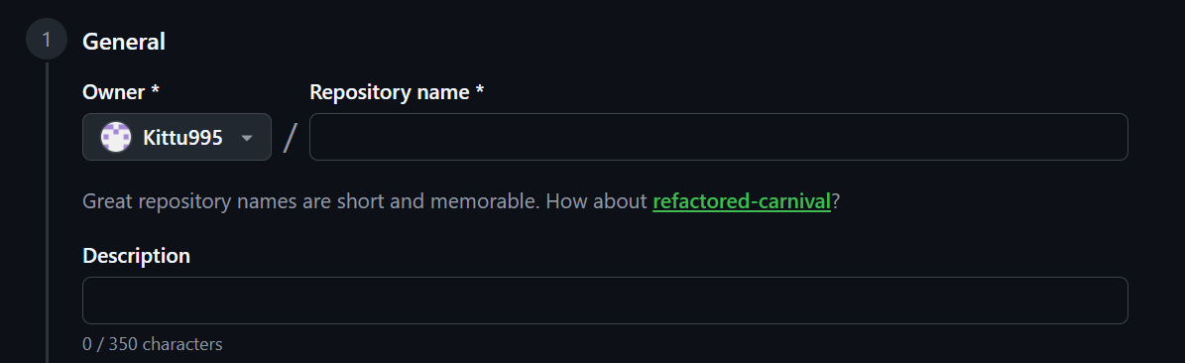

2) By using the remote command to add files to github
The url will see after create the new repository and paste it the url

3) To check the it use this command
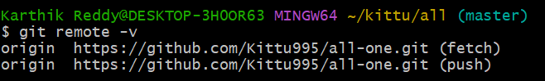
4) To Push the files to github
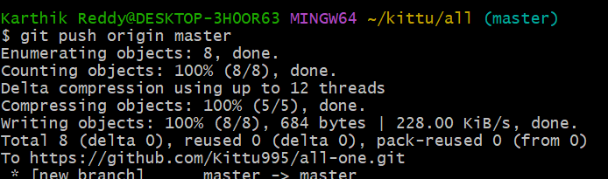

5) I write the code in github how to add it to git
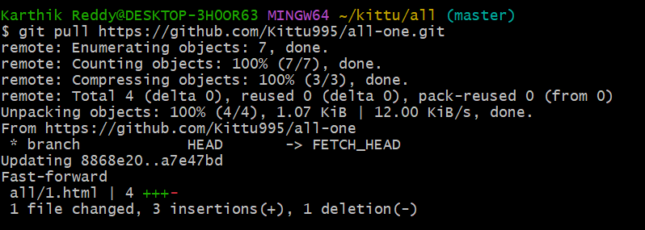
Write the code on github on click on the commit changes it will save after that we want to use the command git pull

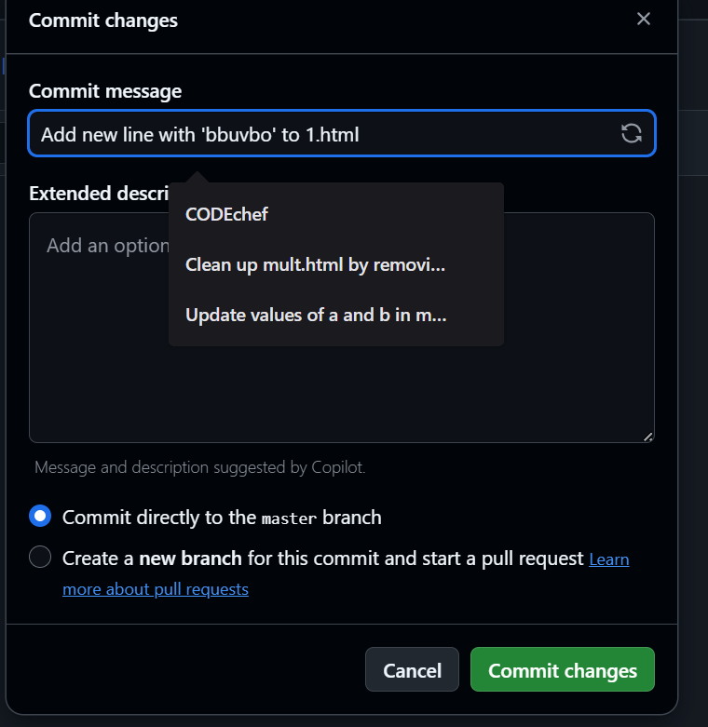

6) git clone command is used for the in the local system has deleted the files it used to get it back
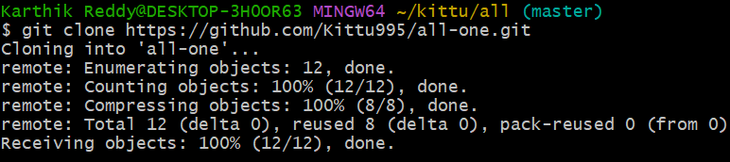
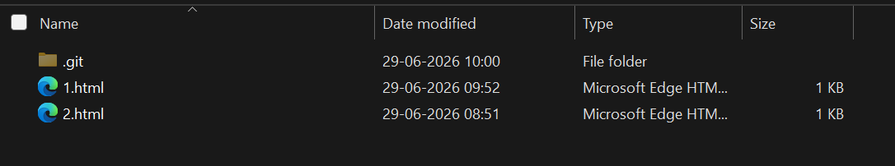

7) How to create the two repositories
Frist create the new repository and copy the url
To check it
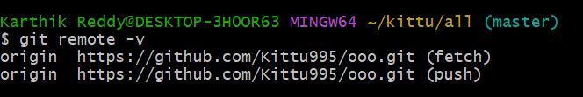
To push it
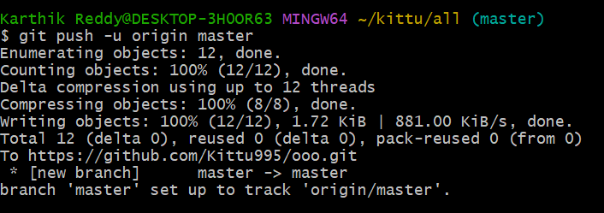

8) About the Stash
Write the code on vs code after that
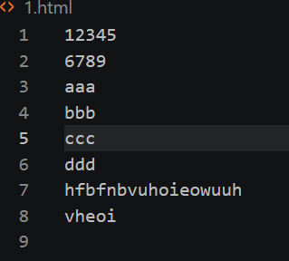
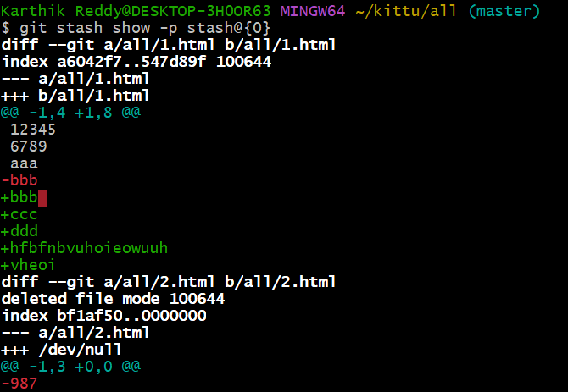
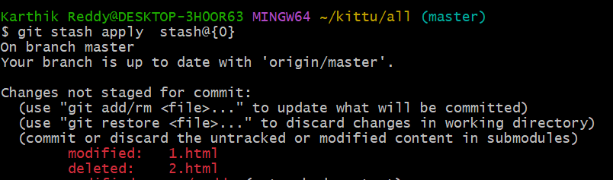

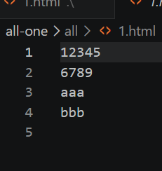

Git branching strategies:

Create the new branch
This command create and switch the branch directly

To edit the branch name

To see the all branch in it
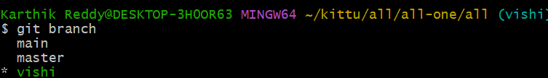

To delete the branch

To switch the branch
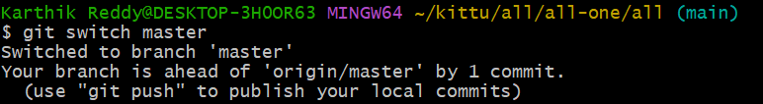

Merge the branches
1)create the file add and commit
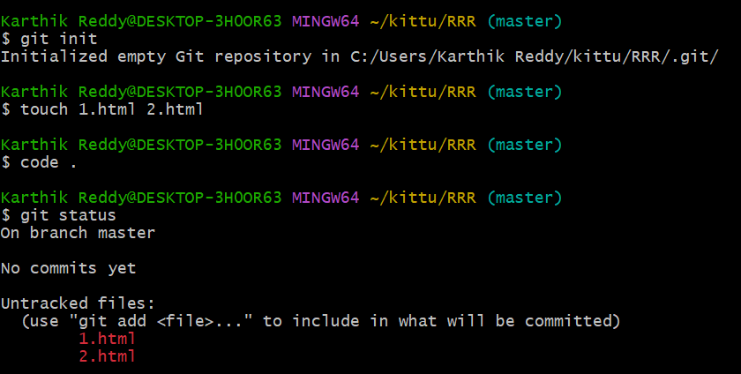
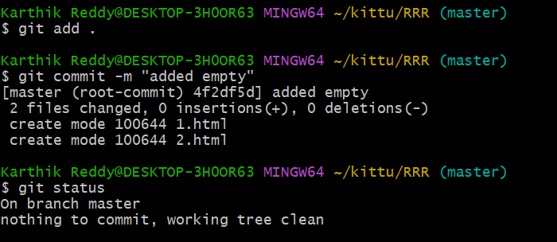

Create the another branch
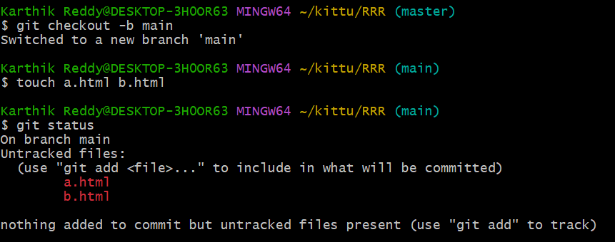
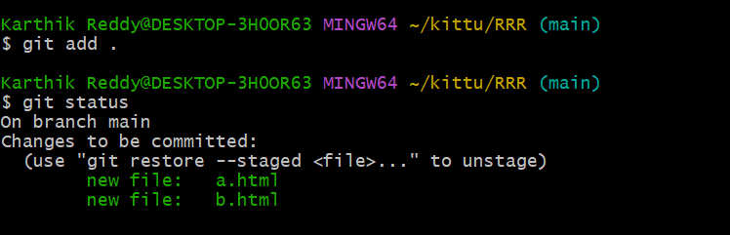
Create the file add and commit it to track
In the main branch I add the two file like a,b html it will show all file in the main branch
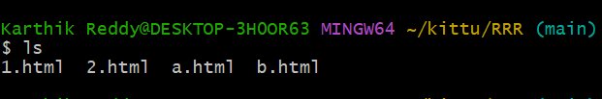

Now check the branch master
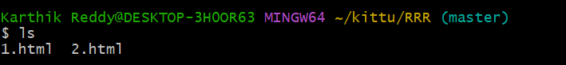

Create the branch vishi and file 4.html add the file commit
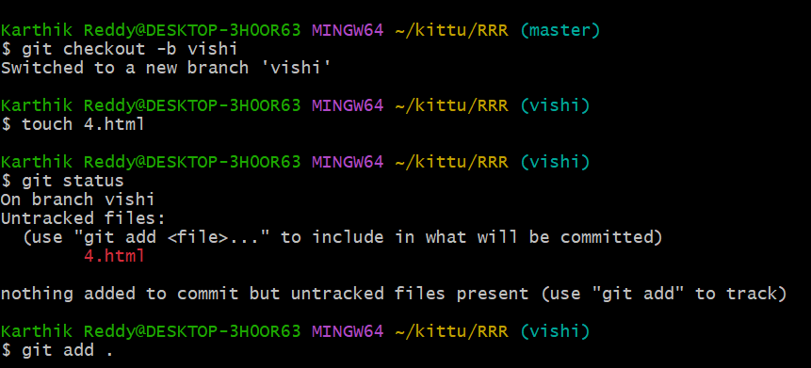

To check the conflicts: Example 1
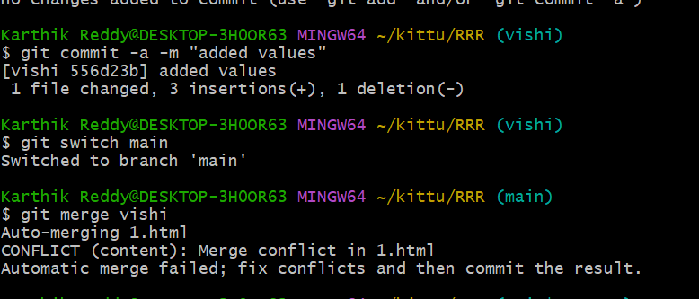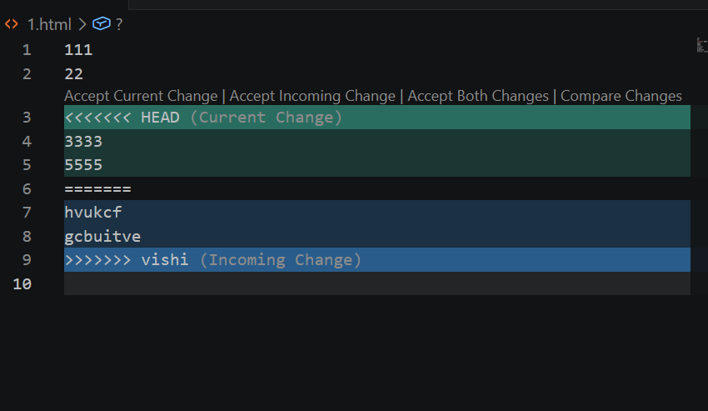

To check the conflicts: Example 2
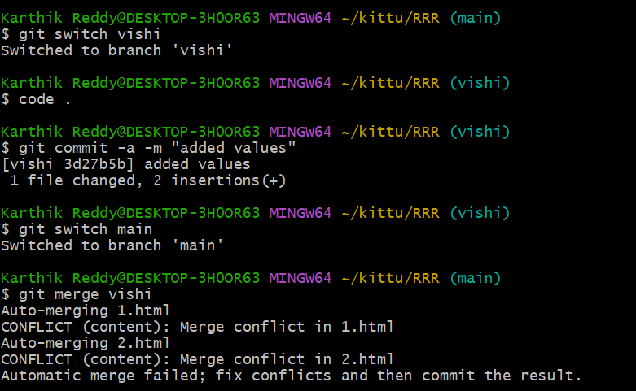

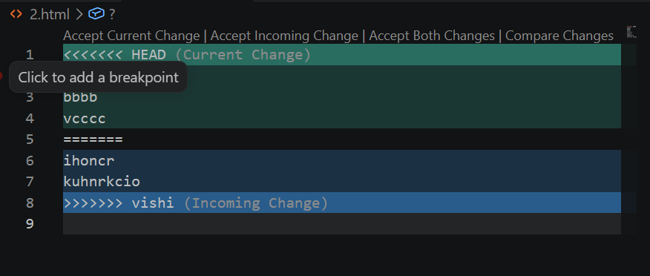

About the reset
“Gitreset soft” By using the this command it will go the staging area while paste the id we want to paste the pervious id

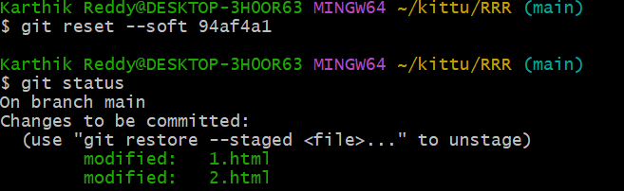

After that I was changed the code and add some content to the code
“git reset –mixed”
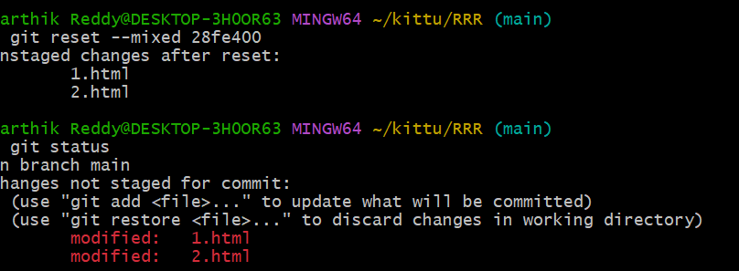
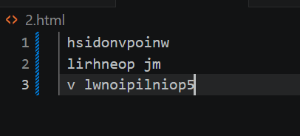

The code was reset
“Git reset –hard” i will delete the code
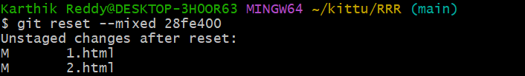
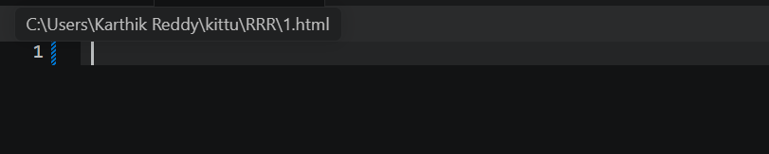

Restore it used to untracked to tracked
“Git restore –staged”
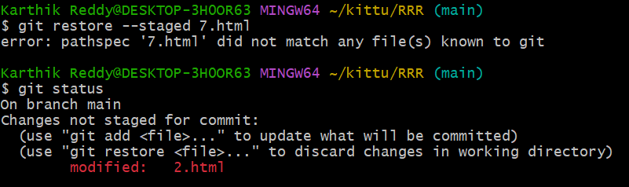
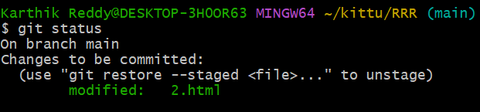

To bring the code back
“Git restore –source”
